**OOPs Lab Tasks**

**Name: -Muhammad Muneeb**

**Reg no: -22108190**

**Date: -18/10/2023**

**Task 1**

**Code: -**

#include<iostream>

using namespace std;

class student

{

public:

string name;

int age;

student()

{

name="unkown\n";

age=0;

};

void input()

{

cout<<"Enter your name and age : ";

cin>>name>>age;

}

void display()

{

cout<<"name : "<<name<<endl;

cout<<"age : "<<age<<endl;

}

};

int main()

{

student m;

m.display();

m.input();

m.display();

return 0;

}

**Output: -**

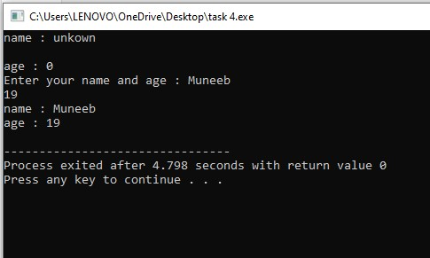

**Task 2**

**Code: -**

#include<iostream>

using namespace std;

class Date1

{

public:

int date;

int month;

int year;

Date1(int birthdate,int birthmonth,int birthyear)

{

date=birthdate;

month=birthmonth;

year=birthyear;

};

void display()

{

cout<<date;

cout<<"/"<<month;

cout<<"/"<<year;

}

};

int main()

{

Date1 m(13,11,2001);

m.display();

return 0;

}

**Output: -**

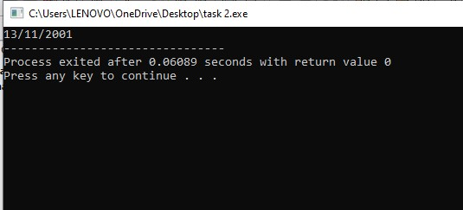

**The End**